**Static Modeling of Predicting 4-CBA in CTA based on Process Parameter and Catalytic Receipt**

1. **Raw material Catalyst and Chemicals**

**1.1 Paraxylene**

Paraxylene used is almost 99.7 percent pure and majorly content impurities as Meta -xylene , Ortho-xylene ,toluene.

**1.2 Hydrobromic Acid (HBr)**

Hydrobromic acid used as promotor for oxidation reaction. Aqueous solution HBr (Con. 47% Wt/Wt )

**1.3 Cobalt Acetate (CoAc)**

This is act as catalyst for oxidation reaction . Cobalt acetate is supplied in aqueous solution of Con. 23.5% Wt/Wt.

**1.3Maganese Acetate (MnAc)**

Maganese is act as also a Catalyst which is supplied in aqueous solution of con. 22.2% Wt/Wt.

Apart from chemicals listed above following chemicals are also uses for different purposes

* Acetic acid ( use as solvent )
* NPA ( Normal propyl acetate as entrainer )
* Oxalic Acid ( use as Catalyst recovery agent )

**2. Properties of Products compounds:**

* **Properties Of 4 CBA :-**

Molecular Weight : 150 gm/mole

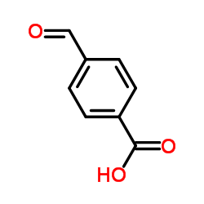Molecular Formulae :

Melting point : 256 oC

Solubility : Slightly soluble in hot [water](https://pubchem.ncbi.nlm.nih.gov/compound/WATER); very soluble in alcohol; soluble in ether and in chloroform, **very lightly soluble in Acetic acid**.

* **Properties of Para-Toluic acid** :-

Molecular Weight: 136 gm/mole

[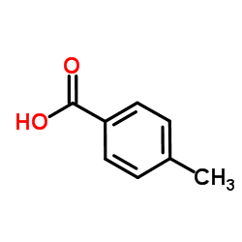](http://www.google.co.in/url?sa=i&rct=j&q=&esrc=s&source=images&cd=&cad=rja&uact=8&ved=0ahUKEwiW-u_vyMzNAhXMRI8KHX7aDrkQjRwIBw&url=http://www.chemspider.com/Chemical-Structure.7190.html&psig=AFQjCNFYplw3oXuduJjgN_KQ1sfb71yCtg&ust=1467266787115728)Molecular formulae:

Solubility: P-Toluic acid is **completely soluble in acetic acid as well as in Hot Water.**

* **CTA (Crude Terephthalic Acid)**
* It is Intermediate product in the production of PTA (Purified terephthalic Acid)
* We almost 99.67% pure terephthalic Acid with major impurities as

|  |  |
| --- | --- |
| Components | % by Wt. |
| Terephthalic Acid | **99.67** |
| 4-CBA | **0.30** |
| Para Toluic Acid | **0.024** |

**2. Reaction Chemistry**

Terephthalic acid (TA) is produced by the liquid-phase air oxidation of paraxylene in acetic acid solvent, and is catalysed by soluble cobalt, manganese and bromine compounds. The overall reaction is as follows:

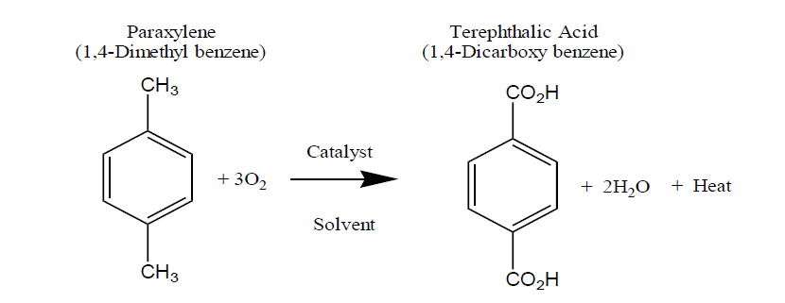

The **reaction is highly exothermic, liberating close to 3,000 kcal (12,500 kJ) per kg of paraxylene** consumed. The reaction proceeds via a series of steps in which each methyl group is sequentially oxidized via the aldehyde to the acid:

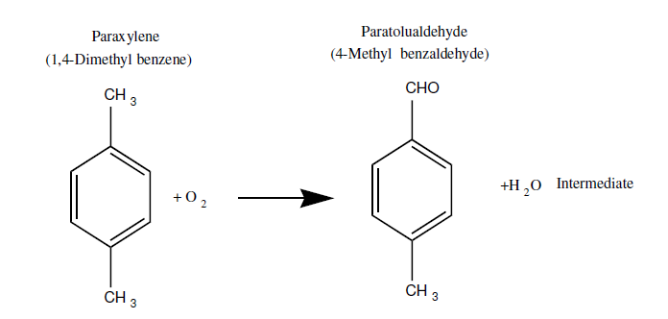

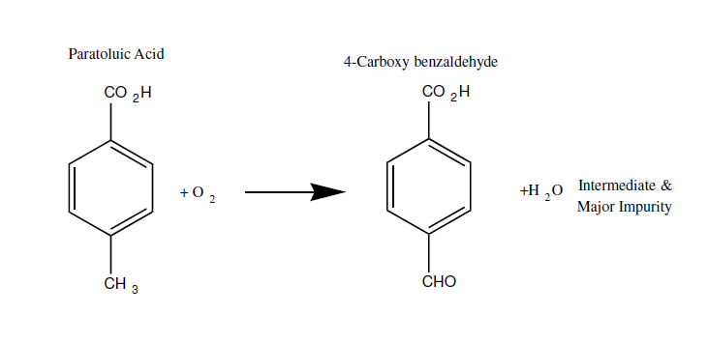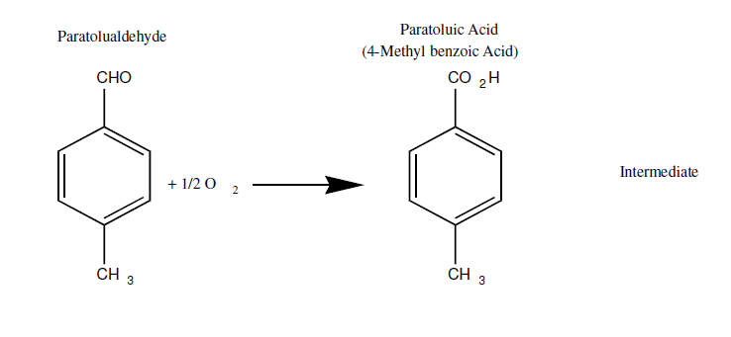

**Slowest step of Reaction**

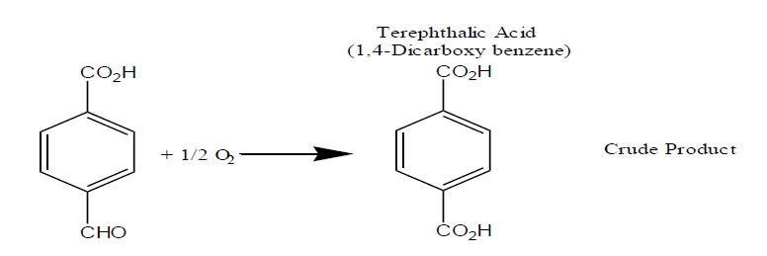

**Crude Terephthalic Acid  
In the above reactions slowest reaction is conversion of P-Toluic acid to 4-CBA. Hence at any instant of reaction the amount of P-Toluic acid is more than that of 4-CBA. Still we get 4-CBA as major impurity because P-Toluic acid is soluble in Acetic acid solvent whereas 4-CBA is insoluble in Acetic acid solvent and precipitated with Terephthalic acid.**

**The amount of 4-CBA in the CTA is very less ( 0.25 – 0.3%) still we expect more pure product. We produce PET from TA by polymerization. During polymerization condensation reaction occurs and form long chain of polymer. But 4-CBA has aldehyde group which does not undergo condensation reaction and cause termination of polymer chain. Termination of the polymer chain at an inappropriate length due to presence of 4-CBA gives poor quality of PET.**

**To get further purity of product we sent CTA to purification section. We remove impurities by reducing it by hydrogenation. 4-CBA hydrogenated with H2 gas and converted to P-Toluic Acid which can further remove by dissolving in the water. There mostly all color causing impurities reduce and we get pure white PTA.**